Name: Pako Ben Ben

Email: pakob775@gmail.com

**TITLE OF WEBSITE:** King HD

1. **WEBSITE SPECIFICATIONS**

**PURPOSE OF WEBSITE**

The reason why I designed this website was because I had realized that most movie and series websites do not meet viewer’s requirements and have limited movies. After realizing this, I designed a website that will be cheap so that students may also use it, access to lots of new movies and series. Also not forgetting the higher quality of videos with low data consumption. And lastly, I may make a living out of it.

Aim is to make the entertainment fun at an affordable price, since it will allow students to have accounts and get discounts. The website will have no age limit since it will have movies that are suitable for any age group.

Technology has evolved and become easily and readily available to the people access is not complicated or sophisticated like back in the days, and kids at a young age(5yrs-12yrs) don’t struggle to use the current and available technology or browse sites like **YOUTUBE.com**

Also, the website will be generating income for me as I will be adding ads of different companies so that they may pay me and make more modifications to my website. Secondly it will create more employment opportunities for undergraduates.

This website is a **Media Website**, on media websites, news stories and other reporting are compiled. There is some overlap with entertainment websites here, while media websites may incorporate reported content about or simply for amusement reasons. This category includes websites such as Goojara, Netflix and Amazon Prime.

Media websites often generate revenue through advertising, subscription models, or a combination of the two. There are several media sites online, many of which are the media branch of media organizations such as TV stations or newspapers, while some are solely available online. There are, nevertheless, media properties.

A good thing is that most of these websites which offer movies are most likely to be closed frequently because they don’t have the **Right Reserved** to publish these movies which is why they mostly appear IN **CAM** Quality. Which is illegal.

For the Major Companies an Advantages against them is that the content they offer is limited cause mostly they focus on Series or long ongoing shows.

Another way to grow your business is to acquire other businesses. Granted, you probably don’t have the cash flow to do that immediately, but it should be part of your long-term growth goals. Just look at how successful companies like Facebook are when they snatch up new technology that they can then roll into their own portfolio, expanding what they do and their audience.

Reinvestment is the single most important thing you can do with profits as it will help your company grow.

Reference link/:[Five Reasons To Reinvest In Your Own Company (forbes.com)](https://www.forbes.com/sites/theyec/2018/10/02/five-reasons-to-reinvest-in-your-own-company/?sh=2e0595572da4)

1. **INFORMATION DESIGN AND TAXONOMY**
2. **Index.html**

The index page will display the links to the categories, movie page, upcoming, contact and feedback.its purpose is draw the attention of the user.

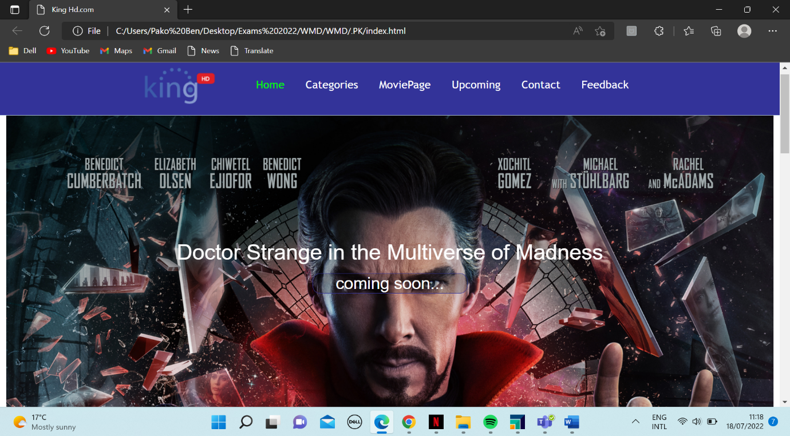

1. **Moviepages.html**

This page is where the existing user will go to browse various movies ,

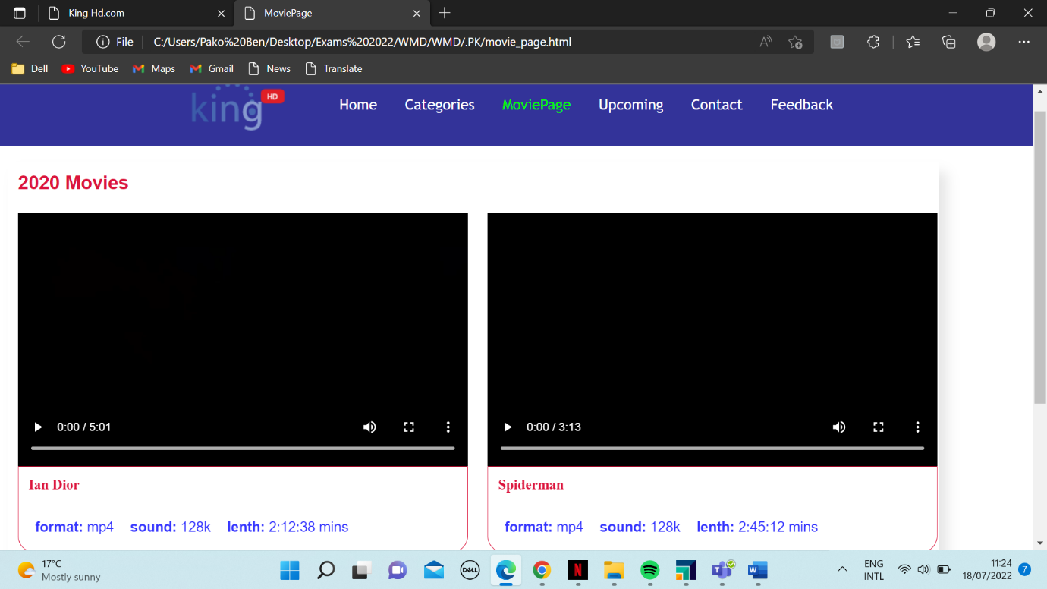

1. **Upcoming.html**

This page is where one can find the details about the upcoming movies, series , documentaries and release dates.

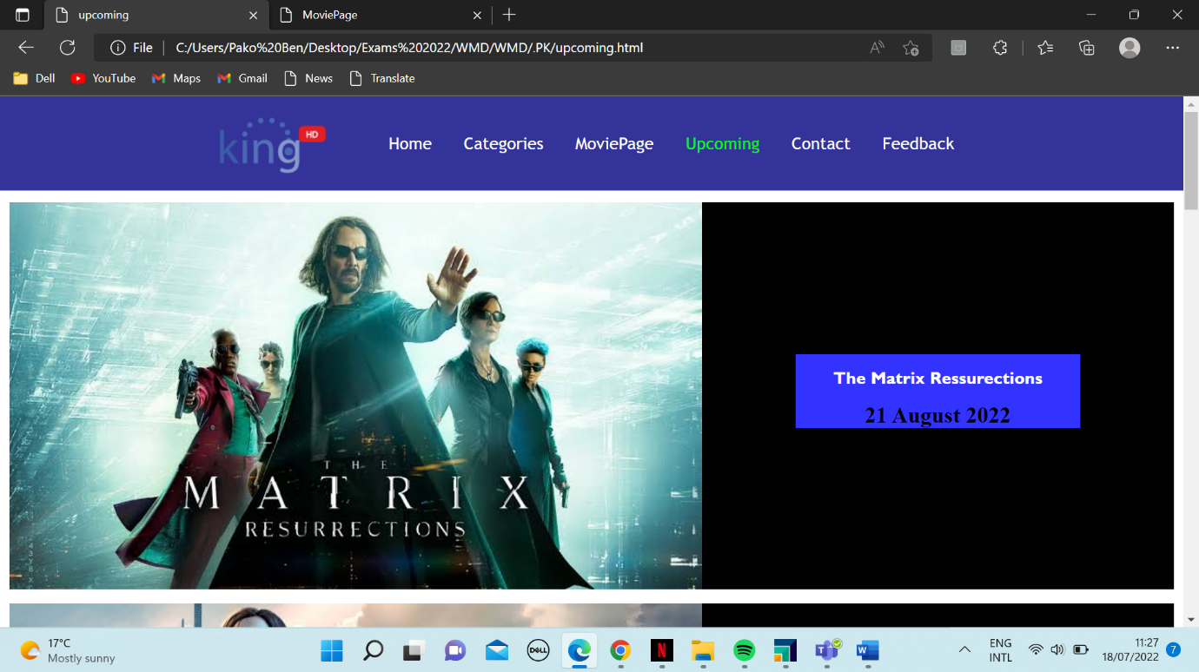

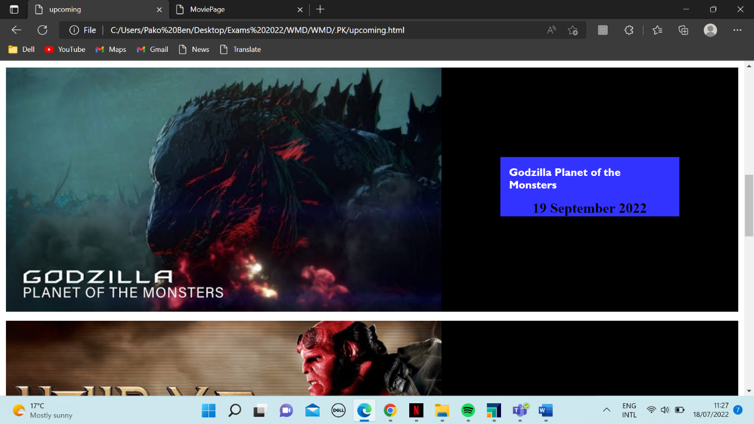

1. **Feedback.html**

This page is where the user can give feedback on the movie they watched and also comment on how we can improve our services. They can also comment on the quality of the picture and sound and their overall experience when using the site.

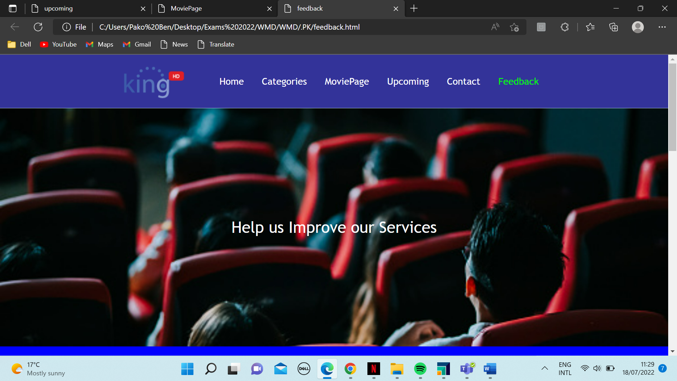

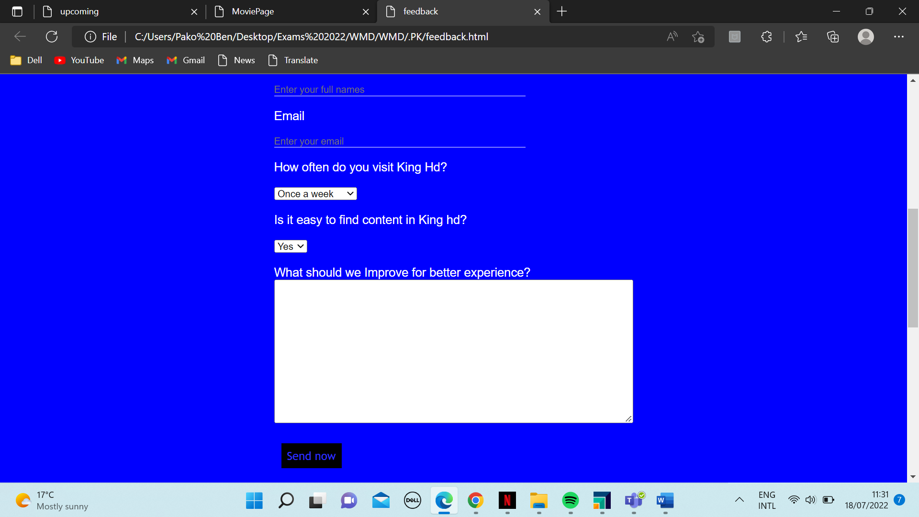

1. **contactUs.html**

This page is where the user of the website may query their complaints or compliments, they will find and contact number, link to our social media and direct contact to some members of our team.

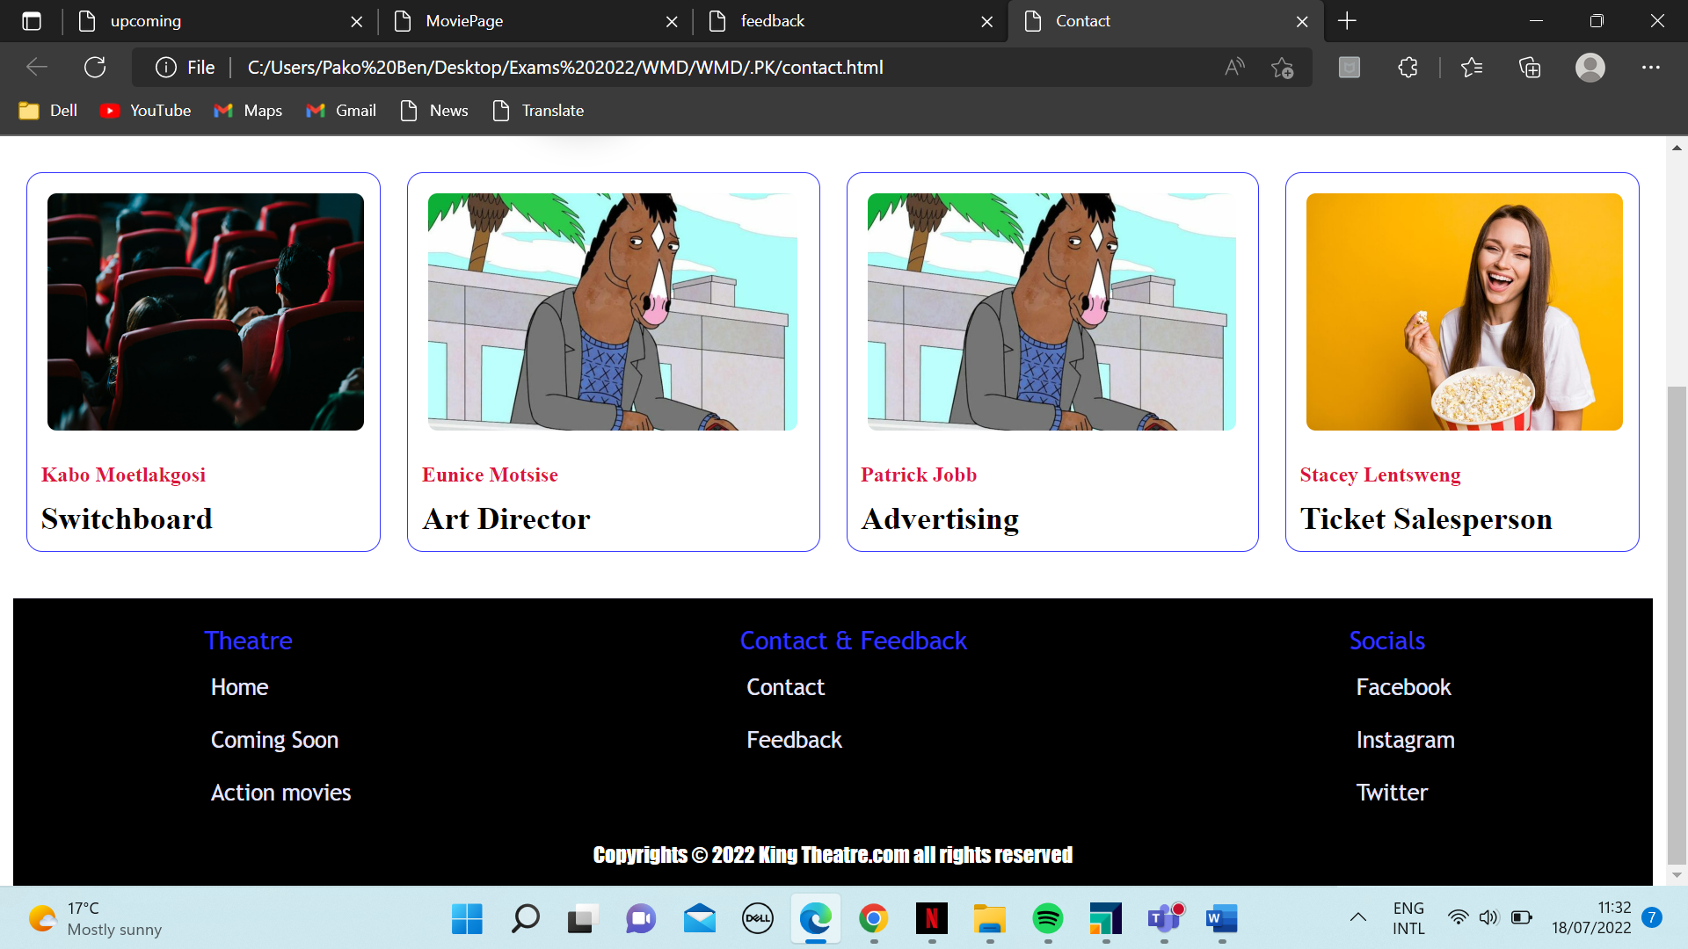

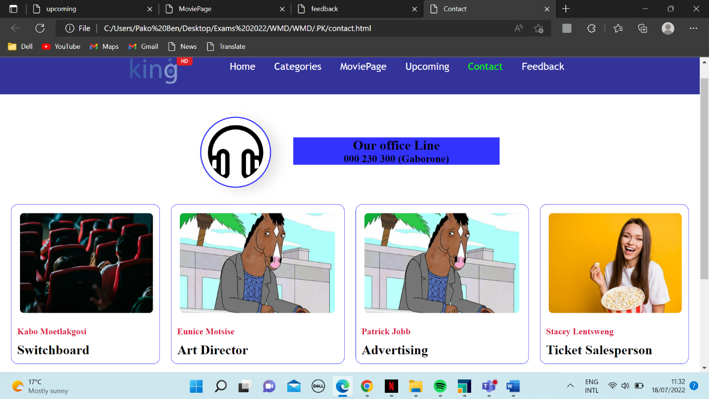

**SITE MAP**

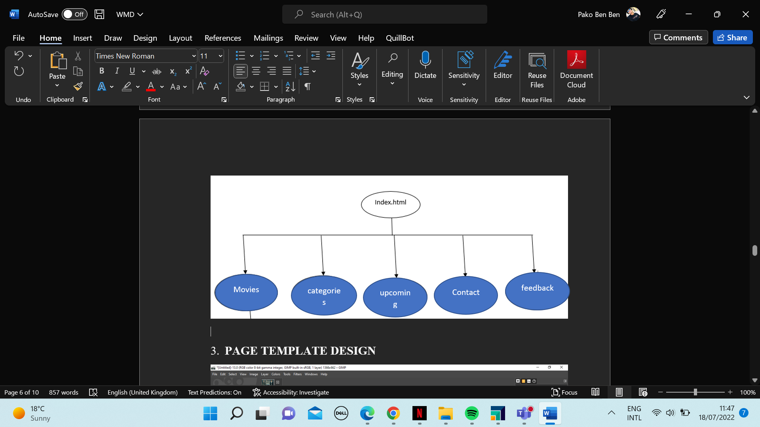

1. **PAGE TEMPLATE DESIGN**
2. **TECHNICAL BRIEF**

**Programming Language:** HTML5 and Java Script

**Style:** CSS3

**Studios:** Visual Studio Code

**Operating System:** Windows 10, 64-bit Processor

**Hardware:** Dell

**Graphic:** GIMP

**STRUCTURE**

All the files are stored in a single folder structure.

**THE FILE**

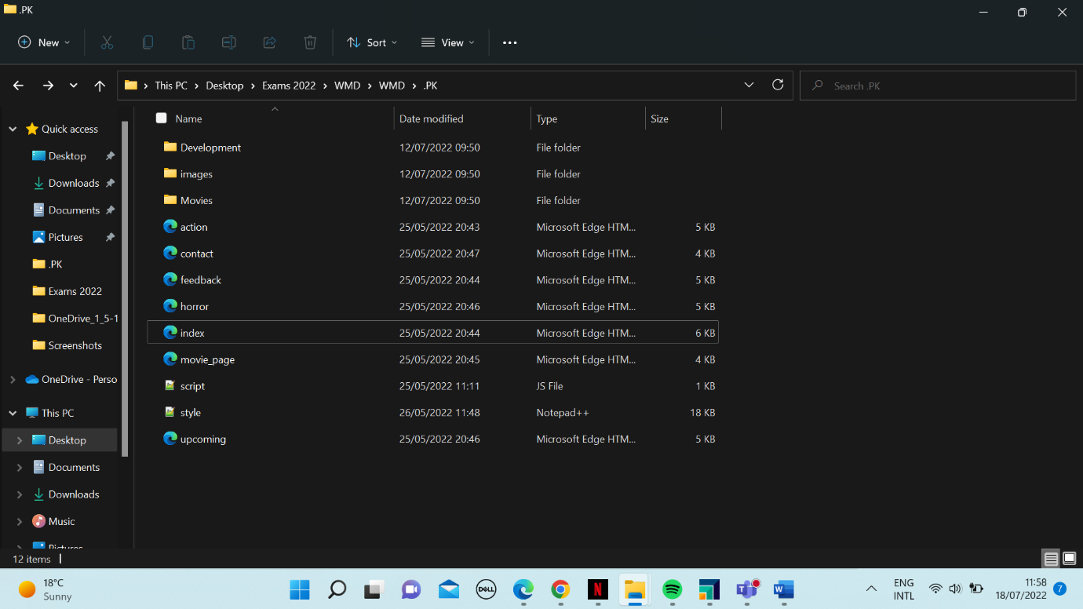

1. **QUALITY ASSURANCE**

I tested the website in Mozilla Firefox, Microsoft Edge and Google Chrome.

1. **Google Chrome**

I did a test on the Google Chrome browser and it ran smoothly, one-click response as expected.

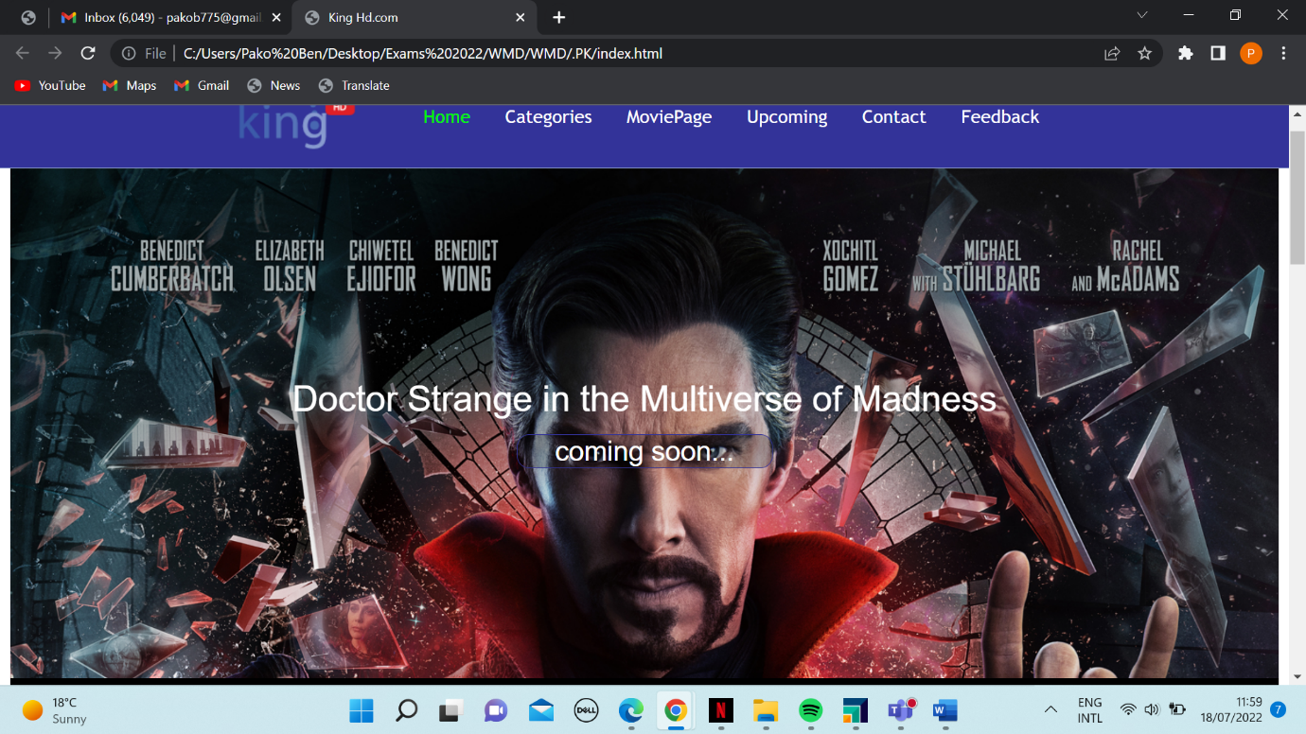

1. **Mozilla Firefox**

I did a test on the Internet Explorer browser and it ran smoothly with a one-click response.

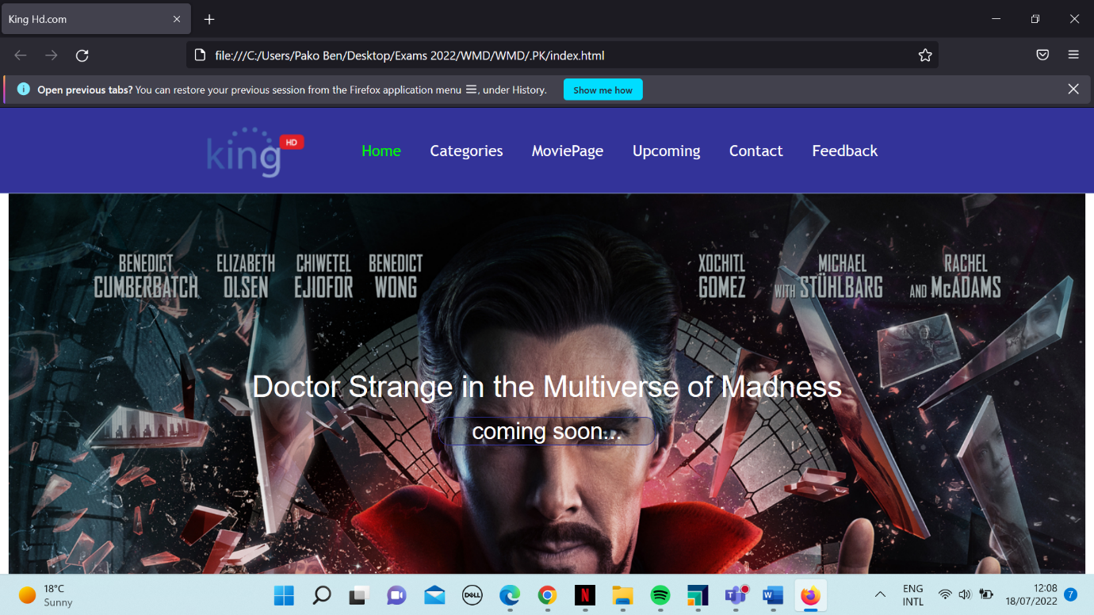

1. **Microsoft Edge**

I did a test on the Microsoft Edge browser and it ran perfectly without any fault. I performed this action three times over to make sure that indeed it was operating flawlessly.

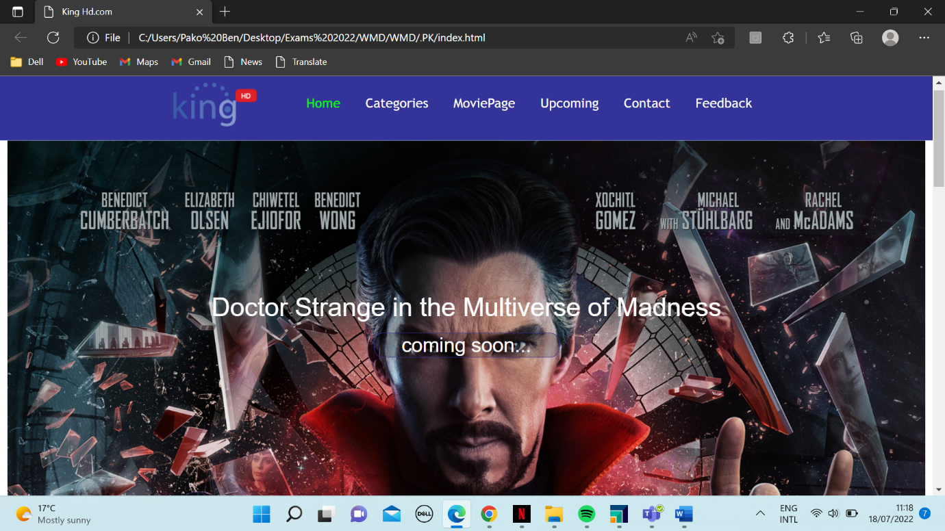

1. **Publishing & Promotion**

I used GitHub to host my website. First thing I did was to download **github** so that I may push the whole document to avoid errors, I created a repository for my website, then I used the following commands.

**git init**

**git remote add origin https://github.com/Bida21021/Bida21-021.git**

**git add .**

**git commit -m “My first commit”**

**git push origin master**

By doing so, my project was uploaded to the GitHub repository.

**TOOLS USED: GIT**

1. **FUTURE DEVELOPMENTS/RECOMMENDATIONS**

* Instead of using JS, CSS, and HTML only, I will also use PHP and Bootstrap to make the website more interesting.
* I will also use Firebase and FireStore Authentication next time to improve the system.
* Keeping the website up-to-date fixes bugs and security holes as well as provides the latest versions of software that typically run better.
* Our next move is to make it even more mobile responsive to increase user accessibility.
* I will include a lead form on the next update in order to follow up on their experience.

1. **GITHUB LINK**

***Here: https://github.com/Bida21021/Bida21-021.git***